1. Which of these terms best describes the type of AI used in today’s email spam filters, speech recognition, and other specific applications?

* Artificial General Intelligence (AGI)
* Artificial Narrow Intelligence (ANI)

1. What do you call the commonly used AI technology for learning input (A) to output (B) mappings?

* Supervised learning
* Artificial General Intelligence
* Unsupervised learning
* Reinforcement learning

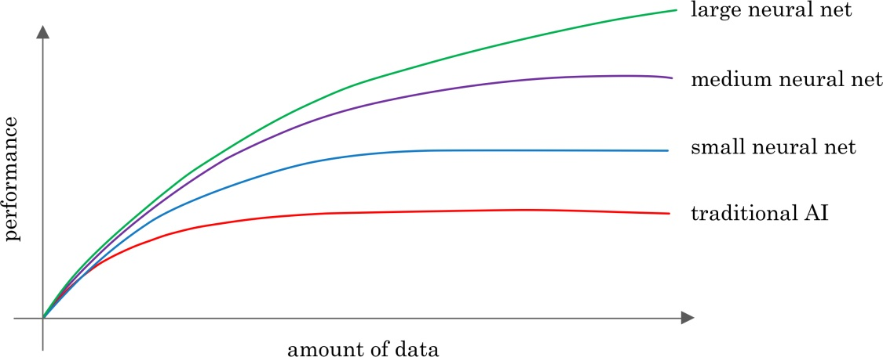

1. You want to use supervised learning to build a speech recognition system. The figure above suggests that in order for a neural network (deep learning) to achieve the best performance, you would ideally use: (Select all that apply)

* A large dataset (of audio files and the corresponding text transcript)
* A small dataset (of audio files and the corresponding text transcript)
* A large neural network
* A small neural network

1. The only way to acquire data for a supervised learning algorithm is to manually label it. I.e., given the input A, to ask a human to provide B.

* True
* False

1. Which of these statements regarding data acquisition do you agree with?

* It doesn’t help to give data to an AI team, because they can always produce whatever they need by themselves.
* Only structured data is valuable; AI cannot process unstructured data.
* It doesn’t matter how data is acquired. The more data, the better.
* Some types of data are more valuable than others; working with an AI team can help you figure out what data to acquire.

1. You run a company that manufactures scooters. Which of the following are examples of unstructured data? (Select all that apply.)

* The number of scooters sold per week over the past year
* The maximum speed of each of your scooters
* Audio files of the engine sound of your scooters
* Pictures of your scooters

1. Suppose you run a website that sells cat food. Which of these might be a good result from a Data Science project? (Select all that apply.)

* A slide deck presenting a plan on how to modify pricing in order to improve sales.
* Insights into how to market cat food more effectively, depending on the breed of cat.
* A large dataset of images labeled as “Cat” and “Not Cat”
* A neural network that closely mimics how cats’ brains work.

1. Based on the terminology defined in Video 4, which of the following statements do you agree with? (Select all that apply.)

* The terms “Machine learning” and “data science” are used almost interchangeably.
* AI is a type of deep learning. (I.e., all AI algorithms are deep learning algorithms.)
* Deep learning is a type of machine learning.  (I.e., all deep learning algorithms are machine learning algorithms.)
* The terms “Deep learning” and “neural network” are used almost interchangeably.

1. Which of these do AI companies do well?

* Strategic data acquisition
* Invest in unified data warehouses
* Spot automation opportunities
* All of the above

1. Say you want to input a picture of a person’s face (A), and output whether or not they are smiling (B). Because this is a task that most humans can do in less than 1 second, supervised learning can probably learn this A-to-B mapping.

* True
* False

1. Machine learning is an “iterative” process, meaning that an AI team often has to try many ideas before coming up with something that’s good enough, rather than have the first thing they try work.

* True
* False

1. Say you want to use Machine Learning to help your sales team with automatic lead sorting. I.e., Input A (a sales prospect) and output B (whether your sales team should prioritize them). The 3 steps of the workflow, in scrambled order, are:

(i) Deploy a trained model and get data back from users

(ii) Collect data with both A and B

(iii) Train a machine learning system to input A and output B

What is the correct ordering of these steps?

* (ii) (iii)
* (i) (iii)
* (iii) (i)
* (iii) (ii)

1. What are the key steps of a Data Science project?

* Collect data
* Analyze the data
* Suggest hypothesis or actions
* All of the above

1. Machine Learning programs can help: (select all that apply)

* Automate visual inspection in a manufacturing line
* Automate resume screening
* Customize product recommendations
* Automate lead sorting in sales

1. Unless you have a huge dataset (“Big Data”), it is generally not worth attempting machine learning or data science projects on your problem.

* True
* False

1. Say you want to build an AI system to help recruiters with automated resume screening. Which of these steps might be involved in “technical diligence” for the?  (Select all that apply.)

* Making sure that an AI system can meet the desired performance
* Making sure you can get enough data for this project
* Ensuring that this is valuable for your business (e.g., estimating the project ROI)
* Defining an engineering timeline

1. Which of these statements about “business diligence” do you agree with?

* Business diligence is the process of ensuring that the AI technology, if it is built, is valuable for your business.
* Business diligence is the process of ensuring that the envisioned AI technology is feasible.
* Business diligence can typically be completed in less than a day.
* Business diligence applies only if you are launching new product lines or businesses.

1. You want to use supervised learning for automated resume screening, as in the example above. Which of the following statements about the Training Set are true? (Select all that apply.)

* It should give examples of both the input A (resume) and the desired output B (whether to move forward with a candidate).
* The Training set and Test set can be the same dataset.
* It should give examples of the input A (resume) but not necessarily the desired output B (whether to move forward with a candidate).
* It will be used by the AI team to train the supervised learning algorithm.

1. For your automated resume screening application, you are now providing a Test Set to the AI team. Which of the following statements about the Test Set are true? (Select all that apply.)

* It should give examples of both the input A (resume) and the desired output B (whether to move forward with a candidate)
* The Test Set should ideally be identical to the Training Set.
* It should give examples of the input A (resume) but not necessarily the desired output B (whether to move forward with a candidate).
* It will be used by the AI team to evaluate the performance of the algorithm.

1. Which of these are reasons that it’s often unrealistic to expect an ML system to be 100% accurate?

* You might not have enough data
* Data can be mislabeled
* Data can be ambiguous
* All of the above.

1. Because smart speakers can carry out multiple functions (such as tell a joke, play music, etc.) it is an example of Artificial General Intelligence (AGI).

* True
* False

1. What are the key steps to a smart speaker function?

* Trigger detection -> intent recognition -> speech recognition -> command execution.
* Trigger word detection -> intent recognition -> speech recognition -> command execution.
* Speech recognition → Trigger word detection -> intent recognition -> command execution.
* Trigger word detection -> speech recognition -> intent recognition -> command execution.

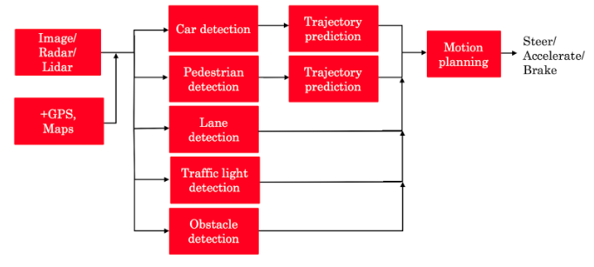

1. The component for pedestrian detection is usually built using:

* GANs
* Reinforcement learning
* Supervised learning
* A motion planning algorithm

1. Suppose you are building a trigger word detection system, and want to hire someone to build a system to map from Inputs A (audio clip) to Outputs B (whether the trigger word was said), using existing AI technology. Out of the list below, which of the following hires would be most suitable for writing this software?

* Data engineer
* AI Product Manager
* Machine learning researcher
* Machine learning engineer

1. What is the first step in the AI Transformation Playbook for helping your company become good at AI?

* Develop an AI strategy
* Provide broad AI training
* Execute pilot projects to gain momentum
* Build an in-house AI team

1. Of the following options, which is the most important trait of your first pilot project?

* Succeed and show traction within 6-10 months
* Drive extremely high value for the business
* Be executed by an in-house team
* None of the above

1. Say you are building a smart speaker, and want to accumulate data for your product through having many users. Which of these represents the “Virtuous circle of AI” for this product?

A

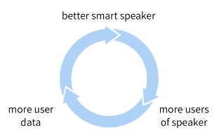

B

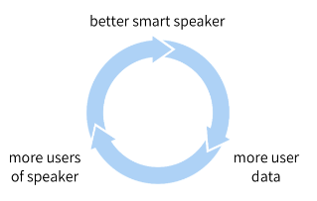

C

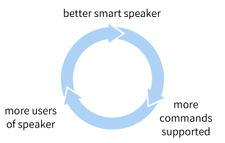

D

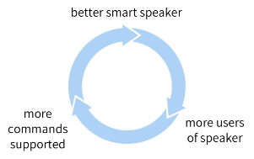

1. Why is developing an AI strategy NOT the first step in the AI Transformation Playbook?

* Without having some practical AI experience and knowing what it feels like to build an AI project, a company usually does not know enough to formulate a sound strategy.
* There is no reason. Developing an AI strategy IS the first step in the AI Transformation Playbook.
* The strategy should be to use the Virtuous Circle of AI, which comes after building a product.
* When transforming a company into an AI company, one does not need a strategy, therefore it can’t be the first step.

1. According to the AI Transformation Playbook, broad AI training needs to be provided not only to engineers, but also to executives/senior business leaders and to leaders of divisions working on AI projects.

* True
* False

1. Which of the following are AI pitfalls to avoid? (Select all that apply)

* Expecting AI to solve everything
* Pairing engineering talent with business talent to identify feasible and valuable projects.
* Expecting AI based projects to work the first time
* Expecting traditional planning processes to apply without changes

1. What are the current limitations of AI technology? (Select all that apply)

* AI technology is susceptible to adversarial attacks
* AI technology can be biased
* AI technology can discriminate
* There are no limitations to AI technology
* Explainability is hard

1. What is the Goldilocks Rule of AI?

* One shouldn’t be too optimistic or too pessimistic about AI technology
* AI’s technology will continue to grow and can only benefit society
* One should allocate many resources to defend the world from giant killer robots
* An AI winter is coming

1. Say you are building an AI system to help make diagnoses from X-ray scans. Which of the following statements about explainability of AI do you agree with?

* AI systems are intrinsically “black box” and cannot give any explanation for their outputs.
* Explainability is usually achieved through building a chatbot to talk to the user to explain its outputs.
* Lack of explainability can hamper users’ willingness to trust and adopt an AI system.
* Most AI systems are highly explainable, meaning that it’s easy for a doctor to figure out why an AI system gave a particular diagnosis.

1. Using current AI technology, if a machine learning system learns from text that reflects unhealthy biases/stereotypes, then the resulting AI software may also exhibit similarly unhealthy biases/stereotypes.

* True
* False

1. Using current AI technology, if a machine learning system learns only from text that is completely neutral and does not reflect any gender biases, then we would expect it to exhibit no, or at most minimal, gender bias.

* True
* False

1. Which of these are good practices for addressing bias in AI? (Select all that apply)

* Systematic auditing processes to check for bias
* Using more inclusive/less biased data
* Technical solution such as “zeroing out” bias
* Using an adversarial attack on the AI system to change its outputs to be less biased

1. Which of these are examples of adversarial attacks on an AI system? (Select all that apply)

* Subtly modifying an audio clip to make a speech recognition system think someone said “Yes, authorized” when they actually said “No, reject.”
* Using AI to synthesize a fake video of a politician saying something they never actually said.
* Adding a sticker to a stop sign to make an AI system fail to detect it.
* Subtly changing an image to make an AI system mistakenly recognize a dog as a cat.

1. If a developing economy has a strong and thriving coffee bean manufacturing industry (or some other vertical industry), then it has an advantage in applying AI to coffee bean manufacturing (or other vertical industry).

* True
* False

1. What are the jobs that AI is most likely to displace over the next several years?

* All jobs will be displaced
* Jobs that comprise primarily of non-routine, non-repetitive work
* Jobs that comprise primarily of routine, repetitive work
* Most jobs involving office work (white collar jobs)

1. Congratulations! You deserve a pat on the back for finishing this course.

* True
* False